**STOCK PRICE PREDICTION**

**INTRODUCTION:**

Stock price analysis has been a critical area of research and is one of the top applications of machine learning. This tutorial will teach you how to perform stock price prediction using machine learning and deep learning technique. There are other factors involved in the prediction, such as physical and psychological factors, rational and irrational behavior, and so on. All these factors combine to make share prices dynamic and volatile. This makes it very difficult to predict stock prices with high accuracy.

**LONG SHORT TERM MEMORY NETWORK:**

Here, we will use a Long Short Term Memory Network (LSTM) for building your model to predict the stock prices of Google.

LTSMs are a type of **recurrent neural network** for learning long-term dependencies. It is commonly used for processing and predicting time-series data. General RNNs have a single neural network layer. LSTMs, on the other hand, have four interacting layers communicating extraordinarily.

**THREE MAIN STEP:**

LSTMs work in a three-step process.

* The first step in LSTM is to decide which information to be omitted from the cell in that particular time step. It is decided with the help of a sigmoid function. It looks at the previous state (ht-1) and the current input xt and computes the function.
* There are two functions in the second layer. The first is the sigmoid function, and the second is the tanh function. The sigmoid function decides which values to let through (0 or 1). The tanh function gives the weightage to the values passed, deciding their level of importance from -1 to 1.
* The third step is to decide what will be the final output. First, you need to run a sigmoid layer which determines what parts of the cell state make it to the output. Then, you must put the cell state through the tanh function to push the values between -1 and 1 and multiply it by the output of the sigmoid gate.

**IMPORT LIBRARIES:**

* from mpl_toolkits.mplot3d import Axes3D
* from sklearn.preprocessing import StandardScaler
* import matplotlib.pyplot as plt *# plotting*
* import numpy as np *# linear algebra*
* import os *# accessing directory structure*
* import pandas as pd *# data processing, CSV file I/O (e.g. pd.read_csv)*

There is 1 csv file in the current version of the dataset:

for dirname, _, filenames **in** os.walk('/kaggle/input'):

for filename **in** filenames:

print(os.path.join(dirname, filename))

**LOADING THE TRAINED DATA SET:**

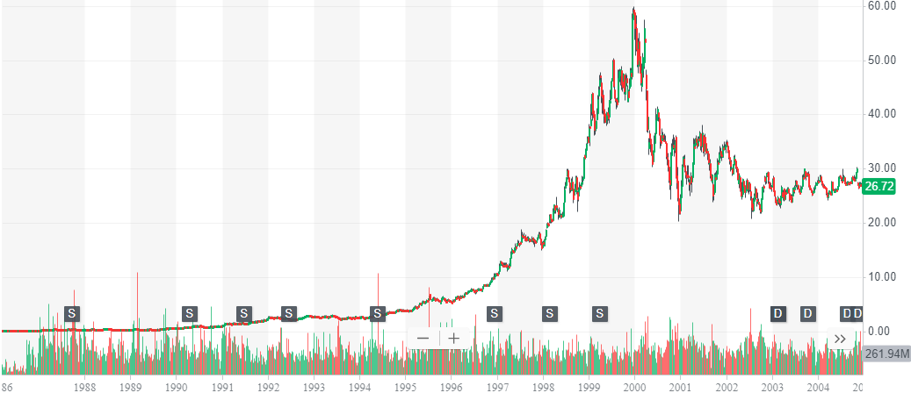

The dataset in the image is a chart of the historical stock price of Microsoft Corporation (MSFT) from 1986 to 2023. The dataset includes the following data points:

* Date
* Open price
* High price
* Low price
* Close price
* Adjusted close price
* Volume

The adjusted close price is the closing price adjusted for splits and dividends. The volume is the number of shares traded on a given day.

The dataset is a valuable resource for investors who are interested in studying the historical performance of Microsoft stock. It can be used to track the company's growth over time, identify trends, and make informed investment decisions.

Here are some additional insights about the dataset:

* The stock price has generally trended upwards over time, with some notable downturns.
* The stock price has accelerated its upward trend in recent years.
* The stock is currently trading near its all-time high.
* The dataset shows that Microsoft is a well-established and growing company.
* The dataset can be used to make informed investment decisions about Microsoft stock.

**SUMMARY:**

This image shows the historical stock price of Microsoft Corporation (MSFT) from 1986 to 2023. The stock price has been on a generally upward trend over the past 37 years, with some notable downturns in the early 1990s, the early 2000s, and the late 2008/early 2009 financial crisis.

The stock price has accelerated its upward trend in recent years, reaching an all-time high of $358.73 on July 18, 2023. As of October 18, 2023, the stock is trading at $332.64, which is still significantly higher than its historical average.

Here is a summary of the key trends in the Microsoft stock price chart:

* The stock price has been on a generally upward trend over the past 37 years.
* There have been some notable downturns, but the stock has always recovered and reached new highs.
* The stock price has accelerated its upward trend in recent years.
* The stock is currently trading near its all-time high.

Overall, the Microsoft stock price chart shows a company that has been growing consistently over time. The company is a leader in the technology industry, and its products and services are used by billions of people around the world.

**The code define functions for plotting data:**

## def plotPerColumnDistribution(df, nGraphShown, nGraphPerRow):

## nunique = df.nunique()

## df = df[[col for col in df if nunique[col] > 1 and nunique[col] < 50]] # For displaying purposes, pick columns that have between 1 and 50 unique values

## nRow, nCol = df.shape

## columnNames = list(df)

## nGraphRow = (nCol + nGraphPerRow - 1) / nGraphPerRow

## plt.figure(num = None, figsize = (6 * nGraphPerRow, 8 * nGraphRow), dpi = 80, facecolor = 'w', edgecolor = 'k')

## for i in range(min(nCol, nGraphShown)):

## plt.subplot(nGraphRow, nGraphPerRow, i + 1)

## columnDf = df.iloc[:, i]

## if (not np.issubdtype(type(columnDf.iloc[0]), np.number)):

## valueCounts = columnDf.value_counts()

## valueCounts.plot.bar()

## else:

## columnDf.hist()

## plt.ylabel('counts')

## plt.xticks(rotation = 90)

## plt.title(f'{columnNames[i]} (column {i})')

## plt.tight_layout(pad = 1.0, w_pad = 1.0, h_pad = 1.0)

## plt.show()

IN:

df1.head(5)

**OUT:**

**Date Open High Low Close Adj Close Volume**

**0 1986-03-13 0.088542 0.101563 0.088542 0.097222 0.062549 1031788800**

**1 1986-03-14 0.097222 0.102431 0.097222 0.100694 0.064783 308160000**

**2 1986-03-17 0.100694 0.103299 0.100694 0.102431 0.065899 133171200**

**3 1986-03-18 0.102431 0.103299 0.098958 0.099826 0.064224 67766400**

**4 1986-03-19 0.099826 0.100694 0.097222 0.098090 0.063107 47894400**

Distribution graphs (histogram/bar graph) of sampled columns:

* **plotPerColumnDistribution(df1, 10, 5)**

Correlation matrix:

* **plotCorrelationMatrix(df1, 8)**

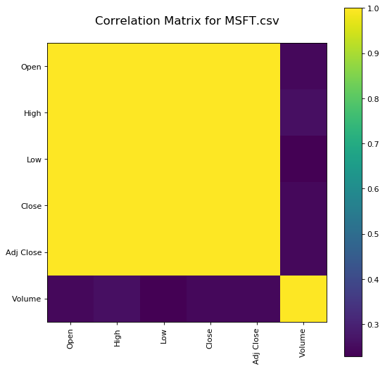

Scatter and density plots:

* **plotScatterMatrix(df1, 18, 10)**

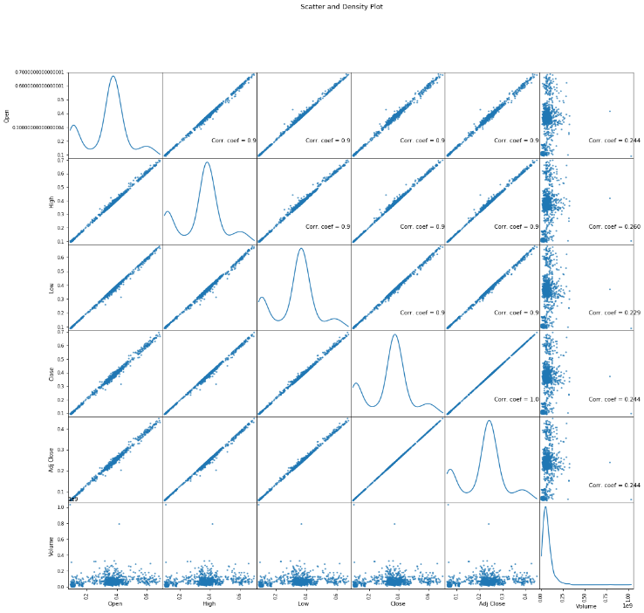

**Conclusion:**

In the conclusion of the Microsoft stock price dataset is that the stock price has been on a generally upward trend over the past 37 years, with some notable downturns. However, the stock has always recovered and reached new highs. In recent years, the stock price has accelerated its upward trend and is currently trading near its all-time high.

Overall, the dataset shows that Microsoft is a well-established and growing company. The company is a leader in the technology industry, and its products and services are used by billions of people around the world**.**